
AUXILIARY PRAYING MEMBERS
LEGION OF MARY
OUR LADY OF PROMPT SUCCOR PRAESIDIUM
SECOND QUARTER OF 2025

He Lives!

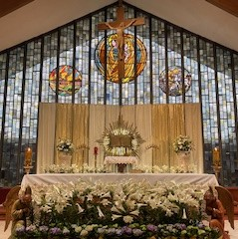

Happy Easter, everyone! Our church is always decorated so beautifully for each of our special holy days. As I was trying to concentrate on the Mass during the week, my mind wandered to the lilies in front of the altar just as Father was consecrating the bread and wine! I noticed the lilies and was reminded of the angels sounding their trumpets and rejoicing in heaven and with us.

Approaching Marian Feast Days:
Come Pray the Rosary with us
at 6:30 followed by the Daily Mass at 7:00 AM

- Our Lady of Fatima, Tuesday, May 13
- Our Mother Of Perpetual Help, Friday, June 27
- Our Lady of Mount Carmel, Wednesday, July 16

We thank everyone who comes to morning mass on these days and recites the rosary with us. Graces are pouring out onto you.
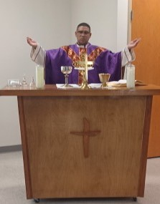

Monthly Mass at the St. Bernard Manor
This photo of Fr. Andy was taken at the St. Bernard Manor. The Legion of Mary visit the St. Bernard Manor once a week and recites the rosary with Manor residents. Fr Marlon or Fr. Andy come once a month for Mass at the Manor.

Thank you for Attending the Acies!
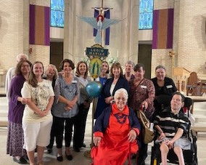

Pictured at St. Rita Church in Harahan: Front Row: Michelle Simoneaux, Stephanie Growl and Merlin Melancon; Second Row: Annette Accomando, Donna Roscher, Pam Richard, Lillian Barras, and Carol Melancon; Third Row: Vic Hattier, Cynthia Hattier, Nanette Hery, Phyllis Ponthieaux, and Juanita Coco. Not pictured but attended: Carolyn Gai, Anne Castjohn, and Lonnie Simoneaux.

The Acies is a yearly event in March where we gather together for Mass and prayers with other nearby praesidia. We also reconsecrate ourselves to Mary during this time. “I am all yours, my Queen, my Mother, and all that I have is yours.” We were grateful to everyone who was able to attend.

NOTES FROM SRI LANKA–In Sri Lanka there are 12 Comitia. They have senior and junior praesidia. Their report includes 350 homes consecrated to the Sacred Heart, 570 children, and 530 adults prepared for the sacraments. One hundred catholics who had lapsed have returned. Thousands take part in their Rosary rallies.

NOTES FROM YOUR PRAESIDIUM–OUR LADY OF PROMPT SUCCOR,
CHALMETTE–Yes, we are still reading through St. Louis de Montfort’s True Devotion to Mary. From February through April we continued doing our weekly works. We feel very blessed that we have new people joining the Legion. The Holy Spirit is truly moving through Our Lady of Prompt Succor Parish.

As always your daily prayers are our lifeline. Your prayers contribute to our success. Thank you for being an Auxiliary Praying Member of our praesidium. Please let one of us know if you attend daily Mass, receive communion, recite all the prayers of the Tessera, pray the Rosary, and pray an Office approved by the Church. Then you would be considered a member known as an Adjutorian!

Finally, Just keep praying. Contact any of us below if you have questions or concerns:

Donna Roscher, President Stephanie Growl, Secretary
504/319-9929 504/812-6450

Pam Richard, Treasurer Annette Accomando, Auxiliary Liaison
504/432-8824 504/214-3863

